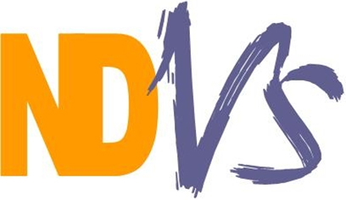

North Devon Voluntary Services Ltd

Registered Charity Number: 1133707

A Company Limited by Guarantee registered in England Number: 6934618

November 2017

Dear Applicant,

Office Administrator

Thank you for your interest in the post of Office Administrator with North Devon Voluntary Services (NDVS).

The enclosed job pack includes the advertisement for the post, the Job Description and Person Specification and an application form including Equal Opportunities monitoring form which needs to be returned with your application.

The role of Office Administrator involves undertaking a variety of day-to-day office and clerical tasks. The post holder will play an integral part in ensuring that our office runs smoothly and is successful in supporting our business activities. The post holder will be situated at our Barnstaple office.

Please return your completed application form marked “CONFIDENTIAL Office Administrator Post” via email or post to Hilary@ndvs.org.uk or Suite 206 Queens House, Queen Street, Barnstaple EX32 8HA.

If you have any questions about the role, please email me at Hilary@ndvs.org.uk.

NDVS supports voluntary, community and social enterprise type groups across North Devon and provides a number of services including training, volunteering advice and information about local services, activities and resources.

The closing date for applications is noon on Thursday 7 December 2017 and interviews will be held on Wednesday 13 December 2017 at Queens House.

Yours sincerely,

Hilary

Hilary Burr
Chief Officer

